Gear Transmission Fault Modeling in Servo Driveline with Compensation Algorithm
First A. Author1, Membership, Second B. Author2, Membership,
and Third C. Author3, Membership
Abstract— This paper present gear transmission dynamics, fault modeling and fault compensation algorithm in the industrial servo drivelines. Firstly, a proper gear system dynamics, mathematical model and basic control structure are defined. After that, fault model and mathematical analysis for compensation algorithm are derived for tooth abrasion or fracture fault scenario. Secondly, a compensation algorithm is developed with using derived fault model. Developed algorithm is embedded to the control structure and compensation algorithm is set for preventing the damage on the driveline and unusual peaks on the speed and torque. System is simulated on Matlab/Simulink environment and tested on the 400W industrial servo motor driven setup. The results show that, developed fault model and compensation algorithm works as a protective structure against such a serious faults.

Index Terms—Gear Fault Diagnosis, Gear Fault Modeling, Fault Compensation Algorithm, Servo Motion Control

INTRODUCTION
G
EAR transmission is the essential part of the servo motor based driveline systems. Generally, the main aim of the gear transmission usage is reducer or booster the speed, also changing the direction (or axis) of the motion. These gear mechanisms can be used alone to transmit motion or in combination with another drive-train. Faults that occur in such critical systems inversely affect the precision of mechanical motion and electronic control system. The first approach for the faulted gear system is modeling the dynamics of the gears and defining the fault situations via gear’s position, speed or torque data. One of the specific studies about this approach is using observer based kinematic error estimator which uses position difference of gear mesh due to fault. Angular position errors of the gears are sampled in spatial domain and signal filtering methods are applied for gear fault diagnostic. In this way, gear tooth surface fault signature waveforms can be recovered. High processing power and memory are required in such signal processing methods [1], [2]. The second approach is using electrical signatures such as analysis of the motor side or driver side phase currents/voltages. According to servo system (gear ratio and load type) and fault specification, the current/voltage profiles change like added noises, peaks or interruptions etc. If the driven system has enough mechanical sensors, faults can detected because, all these effects cause mechanical signatures such as vibrations, impulses, acoustic noise, unbalanced motions etc. On the other hand, frequency domain analysis, reference signal injections, model based solutions (with filtering operations), transfer functions, mapping/categorizing methods, demodulations are used with input/output current/voltage measurements[3]–[6]. Also, the fault diagnostic of the gears can be obtained by using space vector analysis of the phase currents. Periodic behavior of a gear tooth fault produces fault-related frequencies in the stator current and harmonics integer multiple of the rotation frequency in the stator current space vector instantaneous frequency[7].

Third approach fuzzy neural network

LITERATURE REVIEW

Gear Dynamics and Control Structure
A proper gear system transmits the motion via its tooth structure with principle of the thrust with friction. The basic dynamic principle is based on Newton’s second law $(Force=Mass×acceleration)$ as shown in (1).

$\sum{T}=Jα$ (1)

Where, $T$ is torque, $α$ is angular acceleration, $J$ is the mass moment of inertia for the rotational element. After defining torque and inertia relation, another critical definition of the gear system is gear ratio $N_{GR}$ in (2).

$N_{GR}=\frac{w_{m}}{w_{l}}=\frac{r_{l} (or n_{l})}{r_{m} (or n_{m})}$ (2)

Where, $w_{m}$ and$w_{l}$ are angular speeds, $r_{m}$ and $r_{l}$ are radii and $n_{m}$ and $n_{l}$ are the tooth number of motor shaft gear and load shaft gear respectively. The mentioned proper gear system is given in Fig. 1.

Fig. 1. A proper servo motor – gear – load system

The dynamic relation of the proper gear system can be defined via tangential speed $V_{tangential}$ at the connection point of two gears in (3). If the gear system provides (3), we can define power for both motor and load sides in (4).

$V_{tangential}=w_{m}r_{m}=w_{l}r_{l}$ (3)
$P_{m\left(or l\right)}=T_{m \left(or l\right)}w_{m \left(or l\right)}, \left(η= \frac{P_{l}}{P_{m}} ×100\right)$ (4)

Where, $P_{m\left(or l\right)}$refers to power and $T_{m \left(or l\right)}$ refers to torques of motor (or load) side respectively. The efficiency $η$ of the gear transmission is also defined in (4). In the case of defining the reflected torque and inertia from load side to motor side, we can define equality relation in terms of motor and load rotation angles $θ_{m}$ and $θ_{l}$ respectively in (5).

$r_{l}θ_{l}=r_{m}θ_{m} \left(where {\dot{θ}}_{m}=w_{m}, { \ddot{θ}}_{m}=α\right)$ (5)

If we rewrite the (1) in terms of ${ \ddot{θ}}_{l}$ for load in (6), we can obtain the also torque-inertia relation between load and motor side with using (2).

$T_{l}=J_{l}{\ddot{θ}}_{l}={ηN}_{GR}T_{m}$ (6)

After definition the basic equality relations, we can differentiate (5) both side twice in (8) and solve the equation with using (2, 4, 6). The reflected inertia and torque can be obtained in (9-12).

$r_{l}{\ddot{θ}}_{l}=r_{m}{\ddot{θ}}_{m}$ (8)
${ηN}_{GR}T_{m}=J_{l}\frac{1}{N_{GB}}{\ddot{θ}}_{m}→T_{m}=J_{l}\frac{1}{η}\frac{1}{N_{GR}^{2}}{\ddot{θ}}_{m}=J_{ref}{\ddot{θ}}_{m}$ (9)
$J_{ref}=\frac{1}{η} \frac{J_{l}}{N_{GR}^{2}}$ (10)
$T_{m}=\frac{1}{η}\frac{w_{l}}{w_{m}}T_{l}$ (11)
$T_{ref}=\frac{1}{η}\frac{T_{l}}{N_{GR}}$ (12)

Transmission of the motion via gear system is effected by also friction $(T_{f})$, viscous damping $(d)$ and stiffness ($k)$. Friction occurs both motor and load sides and can be modeled as Coulomb friction. Viscous damping is valid for motor side and gears separately. Stiffness can be defined for gears (also it represents the stiffness from shafts). When these parameters are combined for motion equation for a proper gear system (Fig. 1), dynamic motion equations (13, 14) are obtained.

$J_{m}{\ddot{θ}}_{m}+d_{m}{\dot{θ}}_{m}+k\left(θ_{m}-θ_{l}\right)+d_{G}\left({\dot{θ}}_{m}-{\dot{θ}}_{l}\right)+T_{fm}=T_{in}$(13)

$J_{l}{\ddot{θ}}_{l}+d_{l}{\dot{θ}}_{l}+k\left(θ_{l}-θ_{m}\right)+d_{G}\left({\dot{θ}}_{l}-{\dot{θ}}_{m}\right)+T_{fl}=0$ (14)

Fault Scenario and Modeling

Fault Scenario
Gear systems are widely used in servo transmissions with purposes of speed or torque reducer/amplifier or position setting. Such gear systems transfers the motion by friction (teeth) from actuator (servo motor) side to load side. The main problem is, as these gear systems operate, they wear or break mechanically. Or it works with gaps (backlash phenomena) between teeth due to assembly errors. These error conditions cause the teeth to slip over each other from time to time. These errors:
- effect main motion profile from motor to load
- create unexpected torque and speed peaks
- reflected torque and inertia are out of order
- increase steady state errors, feedbacks are fails so this effects the controller
- may lock the gears (broken tooth)

Fig. 2. Tooth fault gear system

When the fault occurs on the gear tooth, the equality relation between speed of the motor shaft and load shaft (3) turns to inequality as shown in (15). Mechanical contact and motion transmission between two gears is distorted.

$V_{tangential}≠ w_{m}r_{m}>w_{l}r_{l}$ (15)

Fault Modeling
In the servo system we have speed/position (encoder) sensor at the motor side. If the speed of the motor shaft creates unusual peaks, we can determine the fault condition. Detection of the speed peak due to fault can be determined by following procedure. Motor shaft speed is tracked by software during maintenance operation time as end of the day or daily operation. If the fault occurs, speed of the motor $w_{m}$ creates a peak (depends on the $K_{p}$ coefficient of the PID controller of the speed) and the position angle $θ_{m}$ increases during fault time as shown in Fig. 3. So the time derivative of the speed (angular acceleration $α$) increases. The main issue is how can we define the sudden change is because of fault or speed command change. To make this distinction, we need to know the speed controller behavior. In a system whose speed is controlled with a PID controller, the speed change is smoother (depends on the $K_{p}$ coefficient of the speed PID controller) with a torque increasing, while the speed changes are robust in case of a fault and torque goes to zero. In this case, if the speed is increased by a reference command, the speed changes with torque need. This means that $i_{q}$ current increases. If the speed changes in case of error, the speed increases but the torque goes to zero. This means that $i_{q}$ current decreases to zero.

Fig. 3. Generic speed - time and rotation angle - time graphs at the fault condition.
For this fault condition, we can create a β indicator which defines the inequality between motor shaft gear speed and load shaft gear speed in (15). At the beginning of the fault β is defined as 1 or 0. β=1, defines has a gear fault, β=0 means system has no gear fault.
After creating β indicator, we can redefine new inequality with unit step $u\left(t\right)$ and dirac delta $δ\left(t\right)$ functions. In this case we can redefine the inequality for fault condition with a coefficient term in (16).

$\left[u\left(t\right)+\left(β×δ\left(t\right)\right)\right] w_{m}r_{m}>w_{l}r_{l}$ (16)

The equations of the motion (13,14) turns into (17,18) because the stiffness $k$ and damping $d_{G}$ of gear turn to zero via the contact loss.

$J_{m}{\ddot{θ}}_{m}+d_{m}{\dot{θ}}_{m}+T_{fm}=T_{in}$ (17)
$J_{l}{\ddot{θ}}_{l}+d_{l}{\dot{θ}}_{l}+T_{fl}=0$ (18)
One of the important characteristic of this type fault occurs periodically. The period of the fault is relative with revolution of the gear and duration of the fault is relative with the angle swept by the faulty teeth. In addition, during starting or when the speed of the load shaft is low, the speed peaks will be higher as there will be more slip in the faulty teeth. As the load shaft accelerates thanks to faultless teeth, fault peaks due to faulty teeth will decrease.

Compensation Algorithm
The main idea of the compensation is eliminate the periodic peaks on the currents due to faults. For this purpose the fault condition must be defined over measured quantities $w_{m}$ and $i_{q}$. When the fault occurs, motor shaft gear loses its contact to load torque that comes from load side. This means that, the speed of the motor shaft gear increases while the torque of the motor shaft peaks to zero. In a discrete time system, present time state and previous time state time difference depends on the fault duration. The recommended delay time $t_{0}$ for the comparison of the $w_{m}(t)$ and $w_{m}(t+t_{0})$, also $i_{q}(t)$ and $i_{q}(t+t_{0})$, is $k$ times bigger of the clock period of the used microcontroller unit. The $k$ coefficient is depends on the microcontroller process capability.

Fig. xx. Generic compensation algorithm flowchart in maintenance cycle.

Implementation of the Compensation Algorithm
In the previous section, fault model characteristic is defined in (16). Motor side shaft speed acts with a coefficient that creates speed peaks when the fault occurs. The second important data is the fault creates the peaks periodically. And then we defined a β fault indicator. So, one of the basic solution for this model is modifying the speed reference signal damped the peaks. We can call this operation as anti-peak fed speed reference injection.

Fig. xx. Anti-peak fed speed reference injection signal input data.

Model Based Estimator/Observer/Predictor
The

Adaptive Control Systems

Others

Simulation of the System

The simulation of the gear fault system is prepared in Matlab/Simulink environment. Firstly the gear fault with backlash model is given in Fig. xx. The broken tooth model is given in Fig.xx.

Backlash Based Fault model

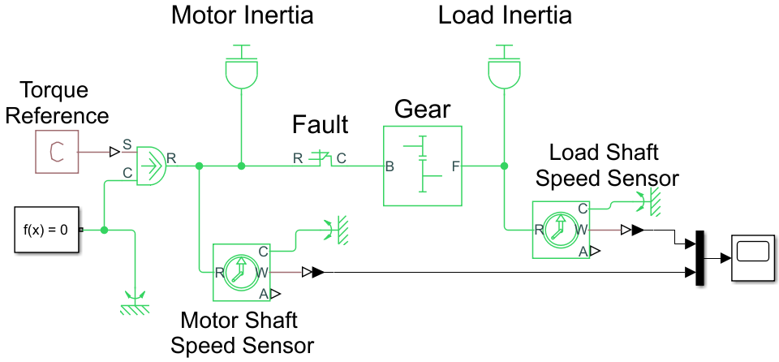

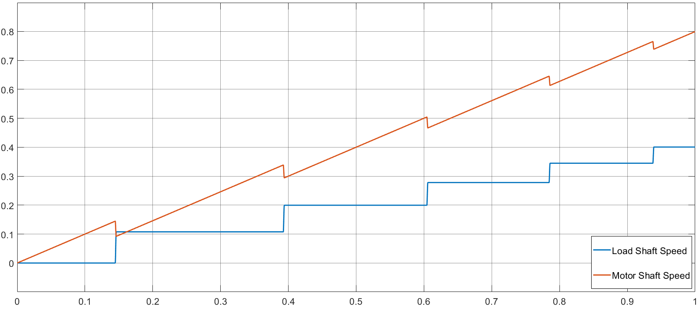

Fig. xx. Gear fault model in Matlab/Simulink environment.

Broken Tooth Based Fault Model
In The broken tooth model represents the fault model caused by broken tooth/teeth. User can define the angle limits at which the error occurs.

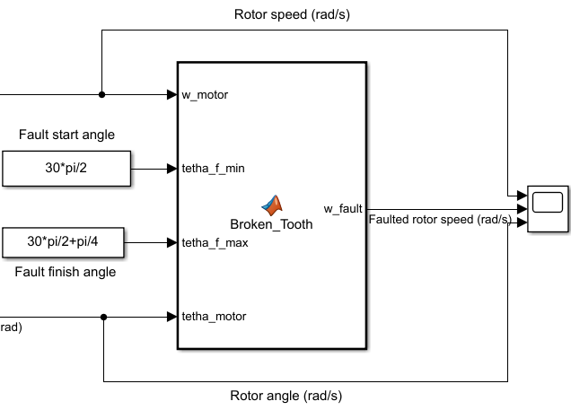

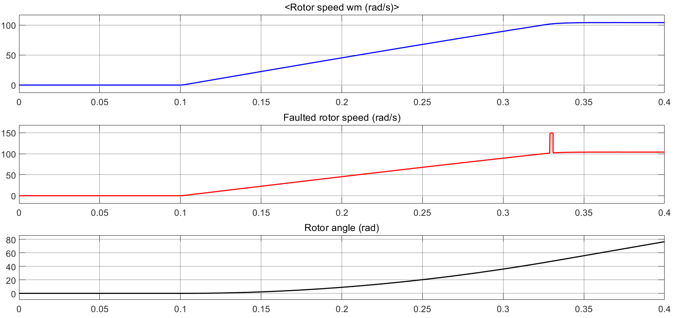
(a) Fault in the area scanned by an angle of $π/4$ at $100rad/s$

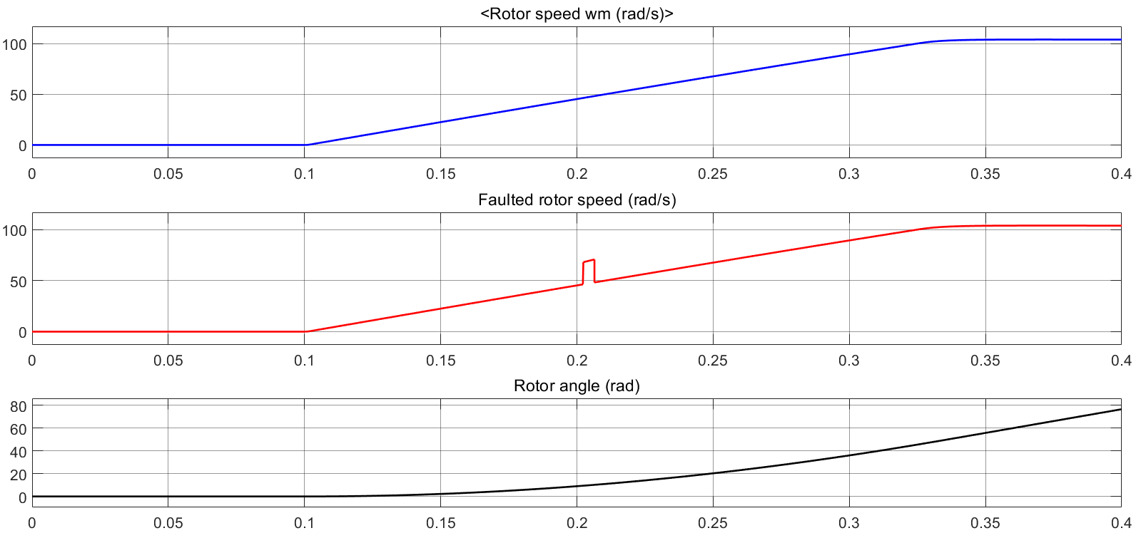
(b) Fault in the area scanned by an angle of $π/4$ at $50rad/s$

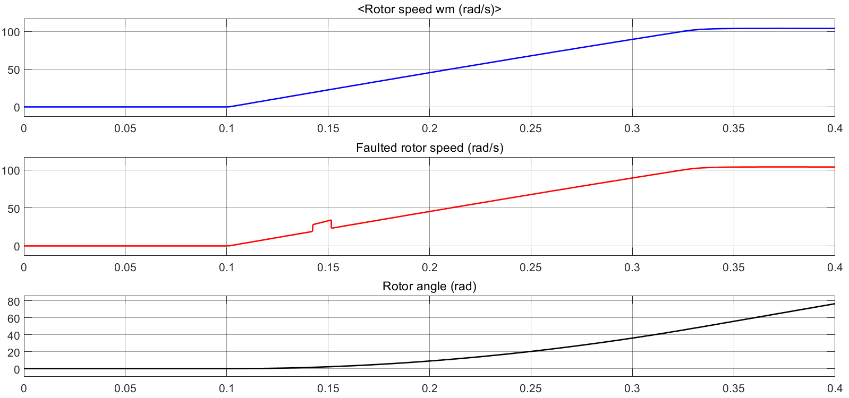
(c) Fault in the area scanned by an angle of $π/4$ at $25rad/s$

Implementation of the System
If you are

Conclusion

Conclusion
A conclusion section is not required. Although a conclusion may review the main points of the paper, do not replicate the abstract as the conclusion. A conclusion might elaborate on the importance of the work or suggest applications and extensions.

References
- F. N. Author1 and F. N. Author2, “The title of the conference,” in Title of the Proceeding, vol. 3, DOI XX/XXXX/ZZZ.XXXX.XXXXXXX, pp. 1–6, Apr. 2003.
- F. N. Author1, F. N. Author2 and F. N. Author3, “The title of the article,” Other Journal, vol. IA-21, DOI XX/XXXX/ZZZ.XXXX.XXXXXXX, no. 4, pp. 814–821, Mar. 1990.
- F. N. Author1, “The title of the article,” Journal title, vol. 56, DOI XX/XXXX/ZZZ.XXXX.XXXXXXX, no. 2, pp. 581–588, Feb. 2009.
- F. N. Author1, F. N. Author2 and F. N. Author3, “The title of the patent,” Jounal Name, no. 146643245, Oct. 1990.
- F. N. Author, The title of the online book, ser. Example Series. P. Name, Apr. 2003. [Online]. Available: http:// books.google.es
- F. N. Author, Title of the book, 3rd ed., ser. series 1. The address of the publisher: The name of the publisher, vol. 4, ch. 8, pp. 201–213, Apr. 1993, an optional note.

First A. Author1 and the other authors may include biographies at the end of regular papers. The first paragraph may contain a place and/or date of birth (list place, then date). Next, the author’s educational background is listed. The degrees should be listed with type of degree in what field, which institution, city, state or country, and year degree was earned. The author’s major field of study should be lower-cased.
The second paragraph uses the pronoun of the person (he or she) and not the author’s last name. It lists military and work experience, including summer and fellowship jobs. Job titles are capitalized. The current job must have a location; previous positions may be listed without one. Information concerning previous publications may be included.
The third paragraph begins with the author’s title and last name (e.g., Dr. Smith, Prof. Jones, Mr. Kajor, Ms. Hunter). List any memberships in professional societies other than the IEEE. Finally, list any awards and work for IEEE committees and publications. If a photograph is provided, the biography will be indented around it. The photograph is placed at the top left of the biography. Personal hobbies will be deleted from the biography.

Second B. Author2 (M’12) was born in City, Country. He received the M. degree in electrical engineering from University of City, Country in 2012.
The second paragraph uses the pronoun of the person (he or she) and not the author’s last name. It lists military and work experience, including similar information to the previous author, including military, work experience, and other jobs. Job titles are capitalized. The current job must have a location; previous positions may be listed without one. Information concerning previous publications may be included.
The third paragraph begins with the author’s title and last name (e.g., Dr. Smith, Prof. Jones, Mr. Kajor, Ms. Hunter), including similar information to the previous author, including the list of any awards and work for IEEE committees and publications. The photograph is placed at the top left of the biography. Personal hobbies will be deleted from the biography.

Third C. Author3 (M’99–SM’04–F’09) was born in City, Country. He received the M. and SM. and F. degrees in electrical engineering from University of City, Country in 1999, 2004 and 2009 respectively.
The second paragraph uses the pronoun of the person (he or she) and not the author’s last name. It lists military and work experience, including similar information to the previous author, including military, work experience, and other jobs.
The third paragraph begins with the author’s title and last name (e.g., Dr. Smith, Prof. Jones, Mr. Kajor, Ms. Hunter), including similar information to the previous author, including the list of any awards and work for IEEE committees and publications. The photograph is placed at the top left of the biography. Personal hobbies will be deleted from the biography.

Manuscript received Month xx, 2xxx; revised Month xx, xxxx; accepted Month x, xxxx. This work was supported in part by the … Department of xxx under Grant (sponsor and financial support acknowledgment goes here). (Authors’ names and affiliation) F. A. Author1 and S. B. Author2 are with the xxx Department, University of xxx, City, State C.P. Country, on leave from the National Institute for xxx, City, Country (e-mail: author@domain.com). T. C. Author3 is with the National Institute of xxx, City, State C.P. Country (corresponding author to provide phone: xxx-xxx-xxxx; fax: xxx-xxx-xxxx; e-mail: author@ domain.gov).

